Final: Image Search and Detection

Group 3:

Cody Ambrose, Rodney French, John Kaiser, Orry Newell

University of Maryland Global Campus

Revision: 1.0

Date: 12/15/2020

Class #: CMSC 495

**Revision Log**

|  |  |  |  |
| --- | --- | --- | --- |
| **Rev** | **Date** | **Editor** | **Description** |
| 1 | 12/3/2020 | Rodney French | Original Document |
| 2 | 12/11/2020 | John Kaiser | Modifications to Design section |
|  |  |  |  |
|  |  |  |  |
|  |  |  |  |
|  |  |  |  |
|  |  |  |  |
|  |  |  |  |
|  |  |  |  |
|  |  |  |  |
|  |  |  |  |
|  |  |  |  |
|  |  |  |  |

1. ~~Overview - including summary of individual contributions~~
2. ~~Project Plan~~
3. ~~Requirements Specification~~
4. ~~System Specification~~
5. ~~User's Guide~~
6. ~~Test Plan and Results~~
7. ~~Design and Alternate designs~~
8. ~~Development History~~
9. Conclusions including lessons learned, design strengths, limitations and suggestions for future improvement

# Overview

Computer vision algorithms are incredibly complex. Because of this, our testing plan will be an evolutionary process. Searching a full scale “Where’s Waldo” image can produce confusing results without a comprehensive understanding of how computer vision algorithms work. We have chosen two processes for locating the desired image: edge matching and feature matching.

Edge matching is finding hard angle in a gray scale representation of an image. This process can aid in distinguishing objects geometrically. For example, a square has four sides but finding four consecutive 90 degree angles could also be criteria for identifying a square.

Feature matching is determining whether the color palette of the image matches that of the target image. Waldo wears red and white stripped clothes. The program will be tasked with finding this coloring pattern. If the program determines that the subject is wearing yellow and black clothing, it may instead be the character Odlaw.

# Individual Contributions

Cody Ambrose – Research, Phase I-III Compilation, Phase I-III coding

Rodney French – Research, Project Plan, Project Design, Compilation of final documentation

John Kaiser – Research, Windows/Mac integration, edge matching algorithm, image input, Phase I-III coding

Orry Newell – Research, GUI design, Phase I-III coding

# Requirement Specifications

Create a Python based application that utilizes computer vision techniques by scanning a user-provided image (JPEG file). Once an image is uploaded, the application will display the provided image and require the user to set a bounded area to be searched. Next, the application will conduct a search for a predefined target image (example: a simple two-dimensional shape, such as a square or triangle). Once the search is complete, the application will display highlighted area(s) that reveal found target image(s).

The detection process should be conducted in near real-time with less than 5 seconds run time for complex puzzles.

The application will present the user an intuitive graphical user interface (GUI) in order to provide a user-friendly experience to users of all experience levels.

The application will be compatible with MacOS and Windows based platforms.

# System Specifications

Development platform: Mac OS 10.15+ and/or Microsoft Windows 8+; minimum 2.0GHz Dual-Core processor; minimum 4 GB RAM; minimum 100 GB HD

Development tools: Python source code; OpenCV; Anaconda v2020.7; Anaconda Navigator; Jupyter Notebook (v6.0.3); Spyder (v4.1.4)

# Software Management

Version control will be handled through GitHub, the URL to the project repository is: <https://github.com/friedunit/CMSC_495_Image_Detection>

Individual assignments under milestones to be directed by the “milestone lead.” Revisions will be provided to this document as they occur.

# User’s Guide

## final_waldo.py

1. Download the Group3_Final.zip folder.

2. Unzip/Extract the contents of Group3_Final.zip folder.

3. From Spyder IDE 4.1.4 using Python 3.8.3, open final_waldo.py.

4. Click the green “Run file” arrow in the tool bar.

5. A GUI should appear (you may need to click over to it in your task bar).

6. Select the “Where’s Waldo” button.

7. The GUI will display a default scene (City) and target image (Waldo).

8. You may choose other scenes from the “Choose scene” dropdown and/or other target image characters from the “Choose character” dropdown.

9. Click the “Preview” button to display your chosen scene to search and target character to search for.

10. Click the “Search” button to initiate image detection for the character you chose.

11. The closest match to the character you chose will be highlighted in a green box within the scene and a zoomed in image of the character in the scene will be provided in the bottom right of the GUI.

12. You may choose other scenes and/or target image characters and repeat the “Preview” and “Search” process to attempt to find the chosen character in the chosen scene or close the application (two windows).

## 

*Note: The target images and “puzzle” images are included in the Group3_Phase3.zip folder at the appropriate file paths for Phase3_Waldo.py to find them. You must run Phase3_Waldo.py from the extracted location within the Group3_Phase3 folder to ensure images are properly pulled and referenced.

# Test Plan, Design and Alternate designs, and Development History

# Overall Design

The purpose of this project is to use computer vision techniques to search for a user selected target image within a user selected large puzzle image. If detected, the target image is bound by a green colored box. The application will be written in the Python programming language and use the open-source computer vision library OpenCV for reading and searching images. As stated in the Project Plan and Test Plan/User Guide, the application will be opened as a desktop icon, launching the “Where’s Waldo” Graphical User Interface (GUI). The GUI itself will be intuitive, with two dropdown menus to select: A) a Scene and B) a Character. The user will then have two buttons to choose from. The “Preview” button will display the selected scene and character for view and the “Search” button will perform the image searching and detection to display the results to the user.

# Files

At the moment, the application consists of a single Python script file that includes the imported libraries, graphical user interface, and all associated methods to perform the functionality of the application. Puzzle images and character target images are stored in separate folders and must be in the same directory as the Python script.

Methods

1. The application begins with the main method that contains the tkinter GUI.
2. The my_preview() method is called when clicking the “Preview” button on the GUI. It gets the selected scene and character from the dropdown menus and reads in the images using openCV’s imread() method. The images are resized for consistency and the appropriate tkinter labels are configured to show the scene and target images in the GUI.
3. To cut down on redundant code, the process_image() method takes a single ‘image’ argument and first converts the image to grayscale using openCV’s cvtColor() method. Next, it converts the image to PIL format from an array and finally converts it to ImageTk format for displaying it in the tkinter GUI.
4. The search_image() method takes two arguments, target_pic and puzzle_pic, and is called by clicking the “Search” button in the GUI. Both images are read in using openCV’s imread() method, then converted to grayscale and apply adaptive Gaussian thresholding for line detection which we found to increase accuracy in results. The size of the target image stored and the scaling and searching begins. A for loop is used to cycle through different scales of the puzzle image and apply openCV’s matchTemplate() method for locating the best results of the target image and puzzle image. The parameters used in the scaling have a large effect on the accuracy and run-time of the results and we are still in the process of optimizing them. Once the best results have been found, the region of interest is saved and a green rectangle is drawn around it with a darkened background to highlight the area for the user. The tkinter labels are configured to show the target image, puzzle image with found target, and a cropped section to make it easier for the user to see.
5. The resize_with_aspect_ratio() method takes two arguments, image and either height or width, to resize the image to the specified dimensions while maintaining correct aspect ratio using openCV’s resize() method.

Fields

The main fields that are being manipulated in the program are the smaller target image and larger puzzle image which are specified by the user from the dropdown menus in the GUI. Once the images are read in with OpenCV, they are converted to arrays.

Interfaces

The TkInter interface will be utilized to create a simple GUI to house and display the application. This will set the bounds for the GUI, as well as the title, buttons, dropdowns, and image display areas. The interface gets the user’s screen width and height to display the GUI in full screen. As stated above, the “Preview” button calls the my_preview() method to display the selected scene and character for the user. The “Search” button calls the search_image() method to conduct the template matching on the selected target and puzzle images and display in the GUI. The TkInter grid() methods organize the widgets on the screen and labels are used to display the images.

Data structures

The images and filenames are stored in target and puzzle dictionaries for efficient retrieval. This allows for easier manipulation for adding, removing, or changing any of the images.

Data file structures

The Python pathlib library was used for file paths to the puzzle and target image folders to allow for operating system independent file paths. It will now run on both Windows and macOS/Linux systems.

Input formats

All images will be preloaded and input as either .jpeg, .jpg, or .png files for both scenes and target characters.

Output formats

Output images will be displayed in the GUI as JPEG formatted images with a highlighted box on the original scene image.

Performance estimates

We estimate that searches will be successfully completed in less than 10 seconds, provided that the user has minimum requirements stated in the original Plan. Changing the scaling numbers has a large effect on accuracy and run-time. Ideally, the template matching takes less than 5 seconds and has an 80% or higher accuracy rate.

Test Cases

Below shows the finalized characters and scenes this application will search as scenes and targets therein said scenes.

Characters left to right: Odlaw, Wizard, Wenda, Woof, and Waldo.

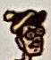 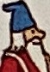 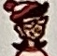 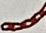 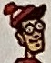

Scenes to search: City, Department Store, Beach, Zoo, Museum, Train Station, and Ski Resort.

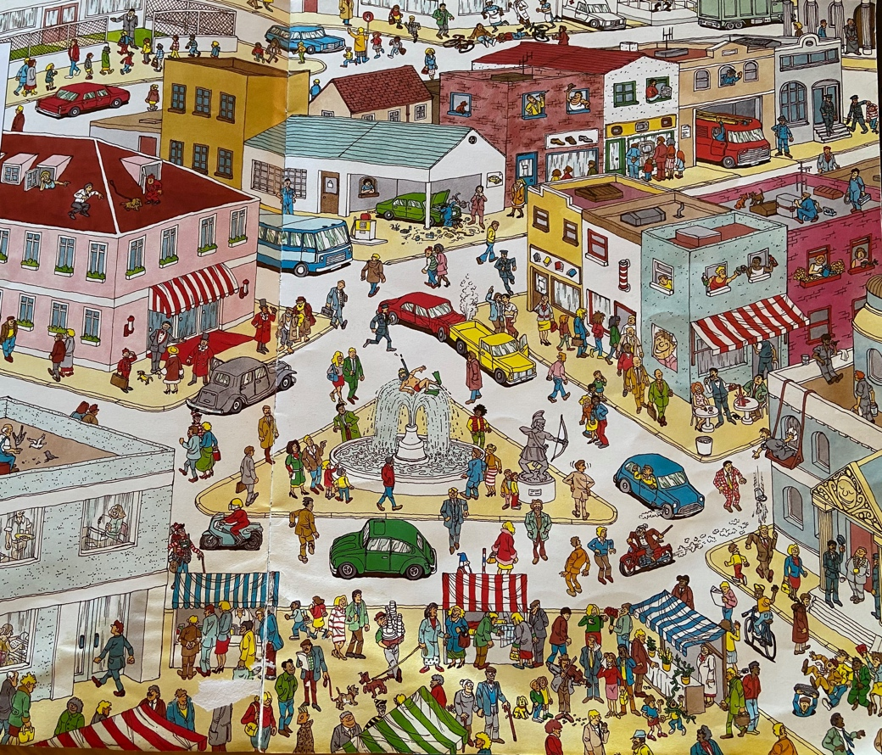

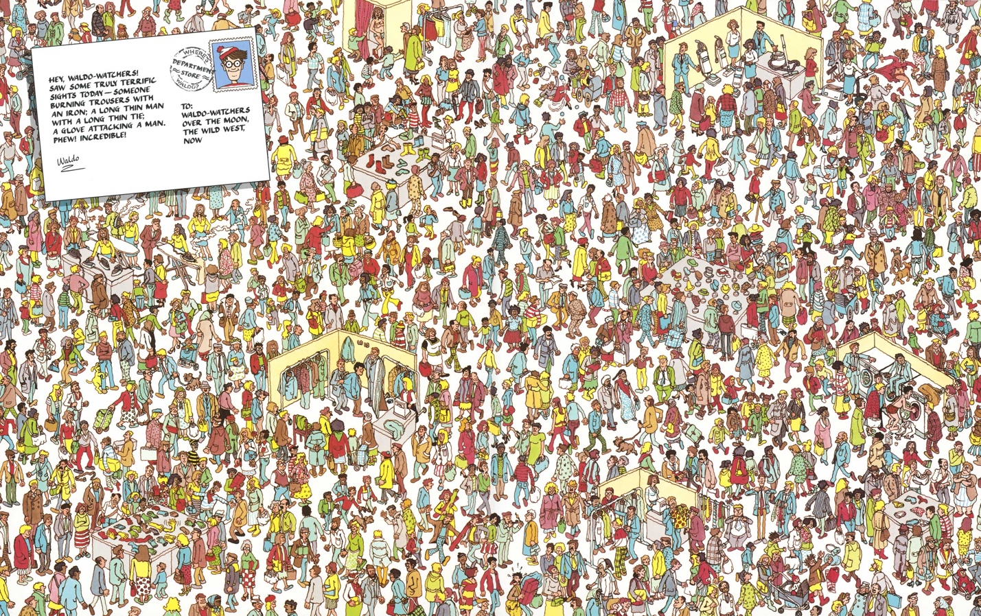

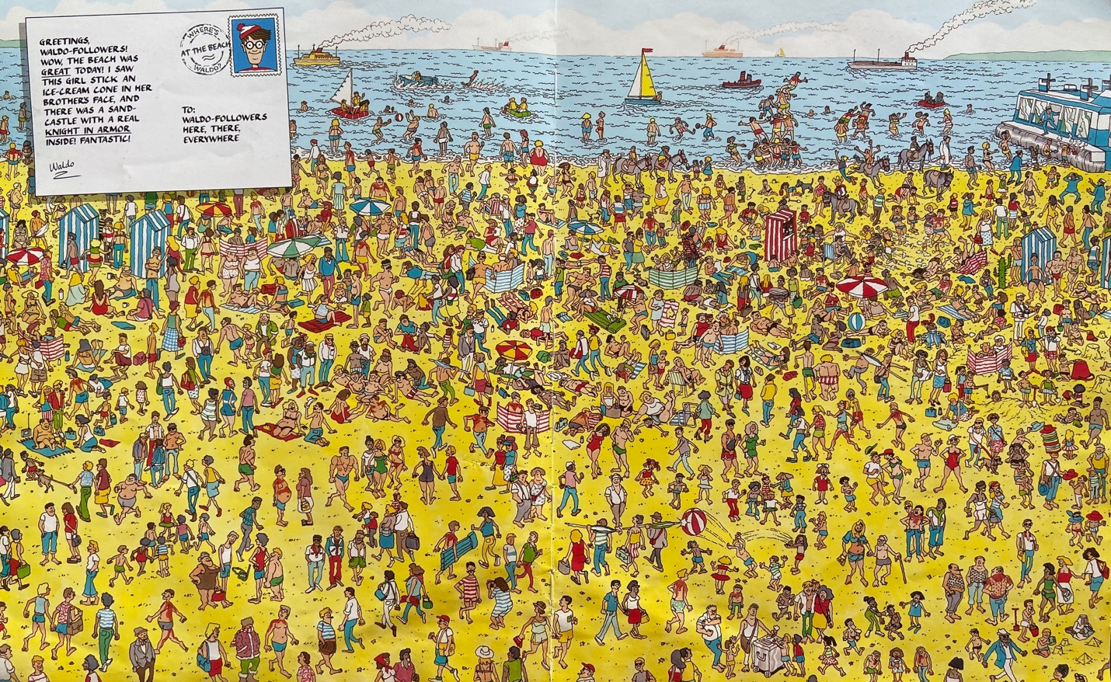

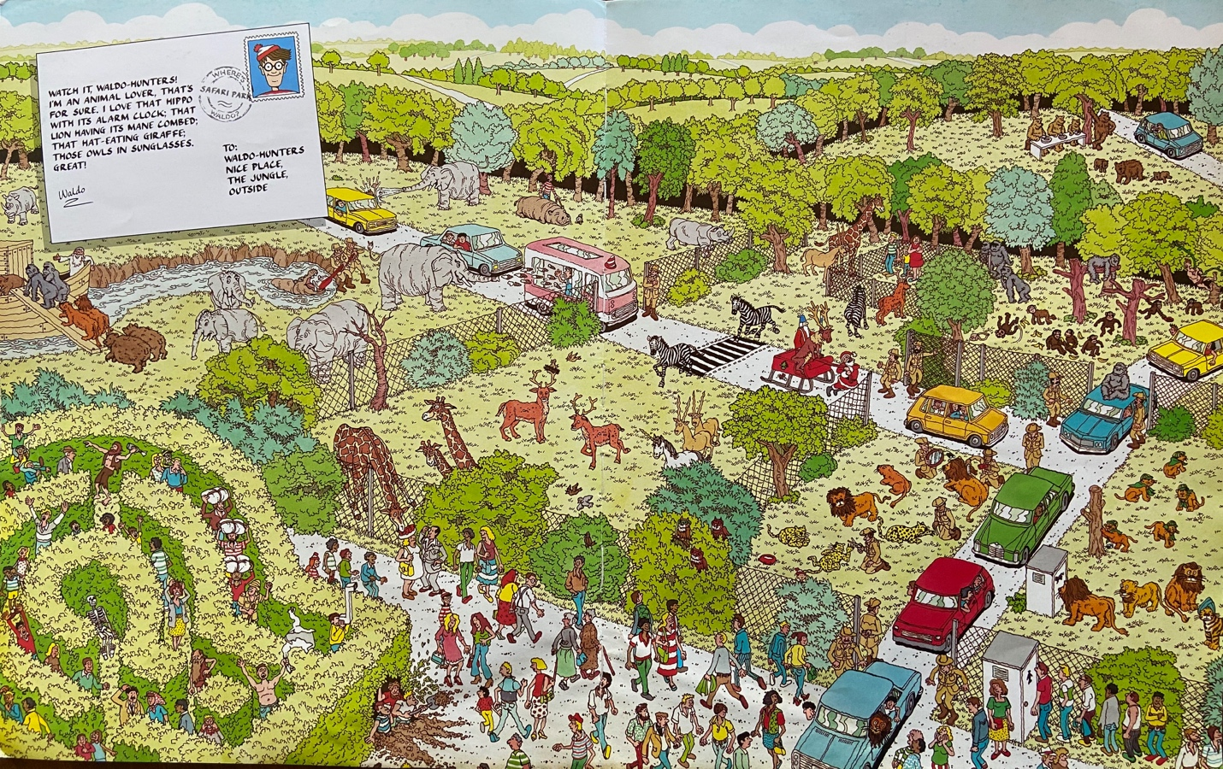

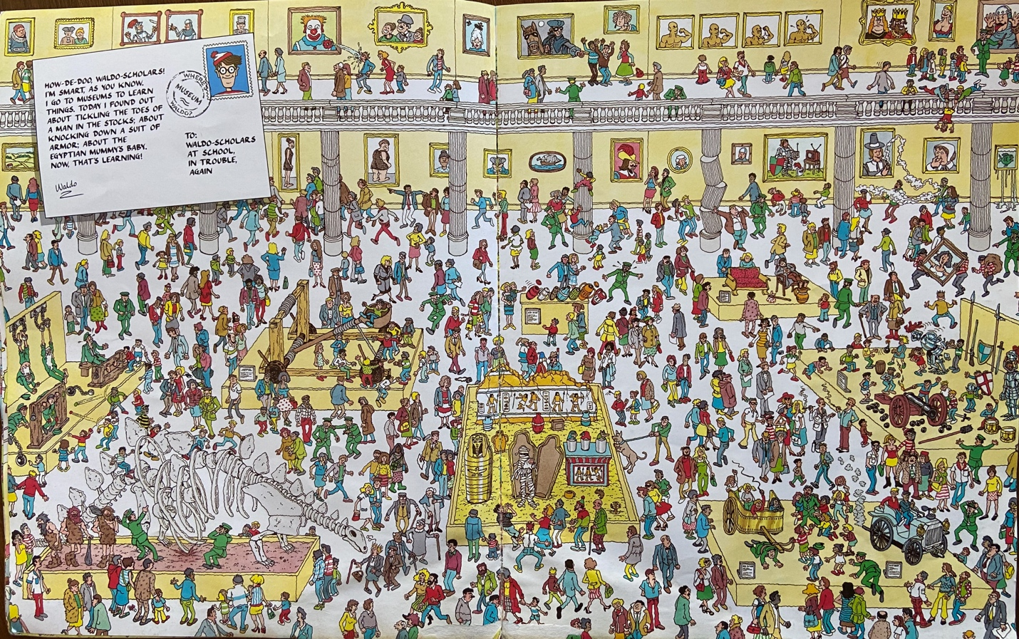

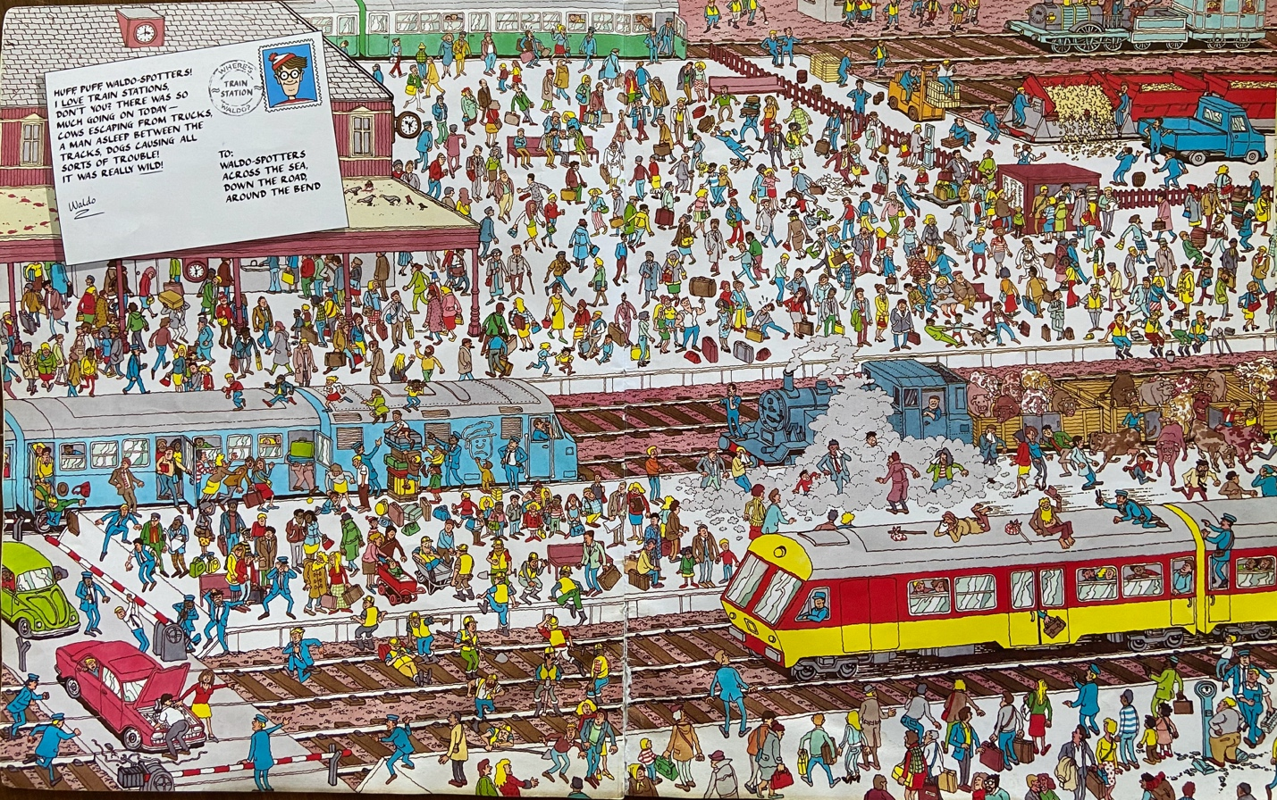

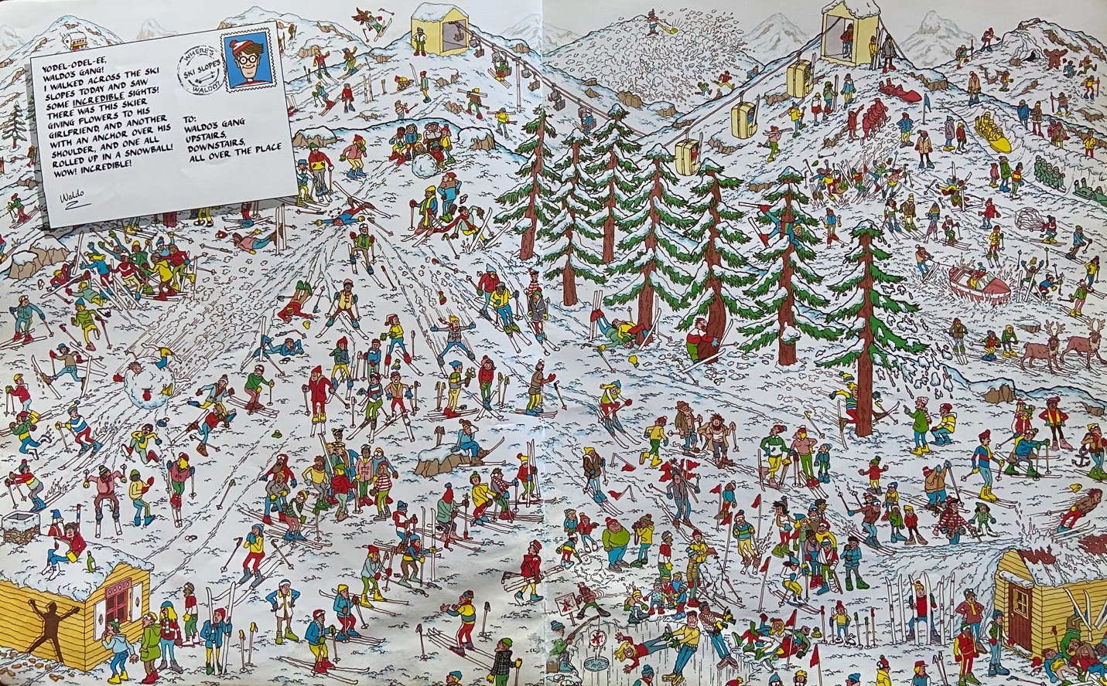

## Phase 1 – Simple Shape/Color Matching

Phase 1 testing will consist of a basic GUI that has a pre-loaded image. The user will have the option to select a basic shape or color. The program will use OpenCV to find the appropriate image. This will give the team a good understanding of how edge matching and feature matching works.

See the below image for an example

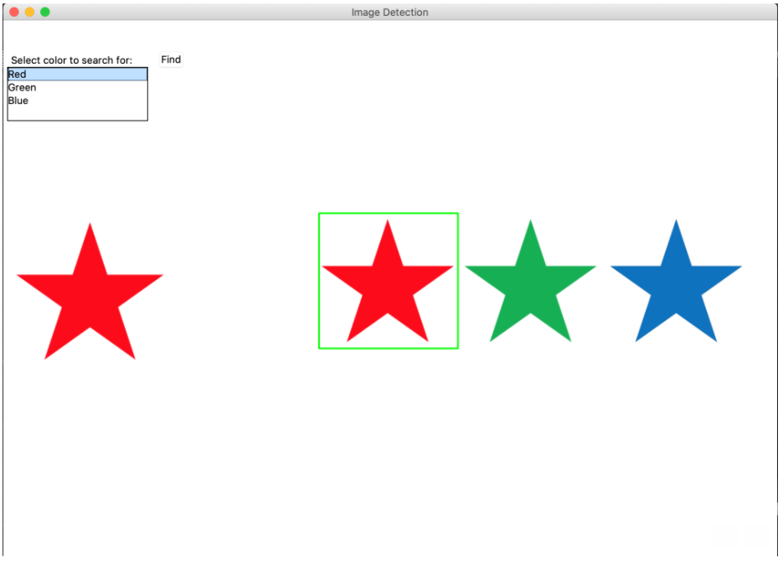

This test should perform as the test matrix below outlines

|  |  |  |
| --- | --- | --- |
| Target Image | Expected Output | Reasoning |
| Square | Program places a box around the square | The program finds the object with 4 sides |
| Star | Program places a box around the star | The program finds the object with 10 sides |
| Triangle | Program places a box around the triangle | The program finds the object with 3 sides |
| Red | Program places a box around red object | The program finds the color matching the RGB value red |
| Green | Program places a box around green object | The program finds the color matching the RGB value green |
| Blue | Program places a box around blue object | The program finds the color matching the RGB value blue |

## Phase 2 – Small Scale Where’s Waldo

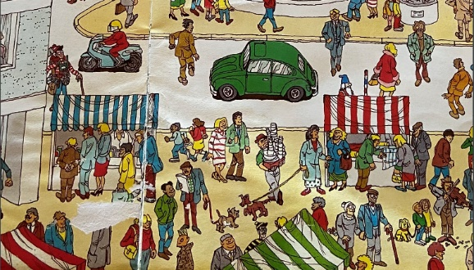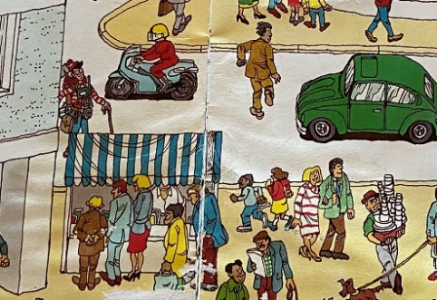The second phase of testing will include small scenes. These smaller scenes will include Waldo and 2-5 other objects. The program will use a base image of Waldo to determine if he is in the scenic image. This phase of testing will slowly be scaled out to include more objects and objects that are easily confused for Waldo use as Odlaw. The scenes will gain complexity as scene below.

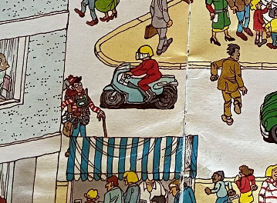

This phase of testing will produce straight forward results. Either Waldo will have a box around him, or he will not. If the box is on Waldo, it is considered a success; if it is not, it will be deamed a failure and the code will be revisited.

## Phase 3 – Full Scale Where’s Waldo & Friends

The original Phase III Milestone was to create a basic GUI with pre-determined images to locate Where’s Waldo characters within full-scale Where’s Waldo puzzles. This was to be accomplished using OpenCV within a Python programming environment. In addition, rescaling of the images and testing of different template matching techniques (i.e. scaling values, etc.) to better identify target images was to be performed in this phase.

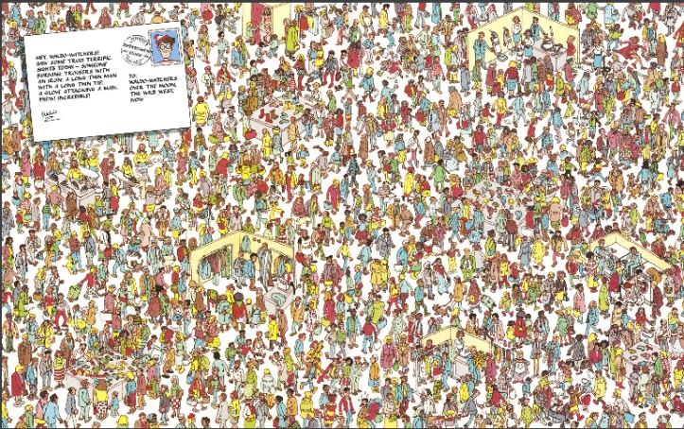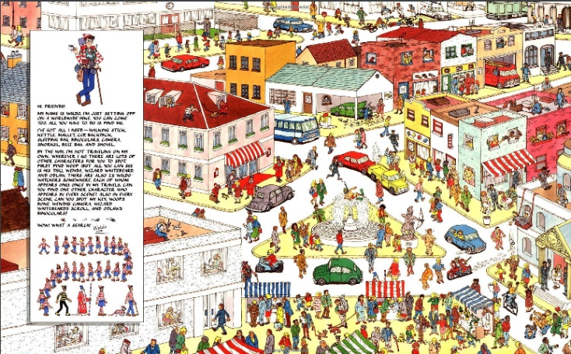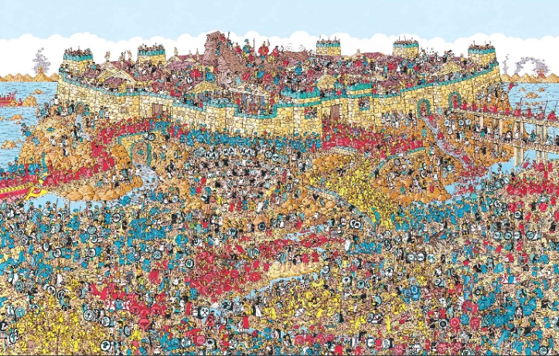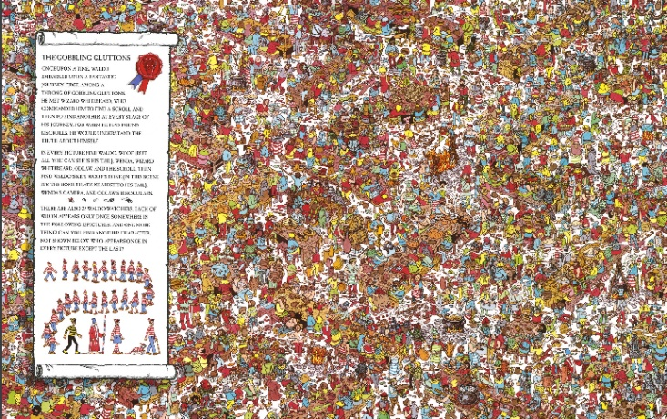Based on the results of Phase III testing, our group is on schedule according to our Phase III milestone. We have successfully developed a Python program, Phase3_Waldo.py, during Phase III that accomplished most of our goals and prompted additional research into methods and techniques. Furthermore, we identified three full-scale (one more than Phase II) Where’s Waldo puzzle images as input (City, Zoo, Ski Resort), as well as five target character images (instead of just Waldo in Phase II) we can use to find the Where’s Waldo characters (Waldo, Wenda, Wizard, Odlaw, Woof). The test matrix below shows the results of Phase III:

|  |  |  |  |
| --- | --- | --- | --- |
|  | **City** | **Zoo** | **Ski Resort** |
| **Waldo** | Found | Found | Not Found |
| **Wenda** | Found | Found | Found |
| **Wizard** | Found | Found | Found |
| **Odlaw** | Not Found | Found | Found |
| **Woof** | Not Found | Not Found | Not Found |

# Problems Encountered

We continued to explore additional methods within OpenCV to identify a target image within a given puzzle image. We found that template matching with adaptive gaussian thresholding (cv2.ADAPTIVE_THRESH_GAUSSIAN_C) still gave us the most accurate results. In addition, our multi-scaling approach from Phase II was carried over to Phase III. We experimented with different scaling values to hone the accuracy of finding Waldo and his friends.

# Reevaluation

Reflecting on the results of Phase III, we believe that our choice of Python and OpenCV is still the most appropriate solution for our larger “Where’s Waldo” project we are building towards. However, our results show that even with our fine tuning in Phase III, we did not achieve 100% accurate results. Additional research in edge detection and feature matching is necessary as we build towards more complex Where’s Waldo puzzles for Phase IV. We also believe that our choice of tkinter for the GUI interface, pathlib library for file paths (to standardize our data file structures across operating systems), input formats (.jpg, .jpeg, .png), output formats (.jpeg), test cases, and performance estimate benchmarks are all still appropriate to carry on to Phase IV.

# Results

## Phase3_Waldo.py

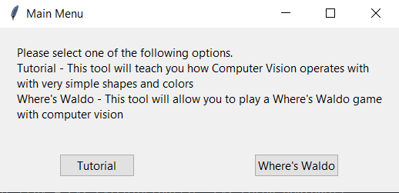

The initial GUI that launches when running Phase2_Waldo.py, click “Where’s Waldo”.

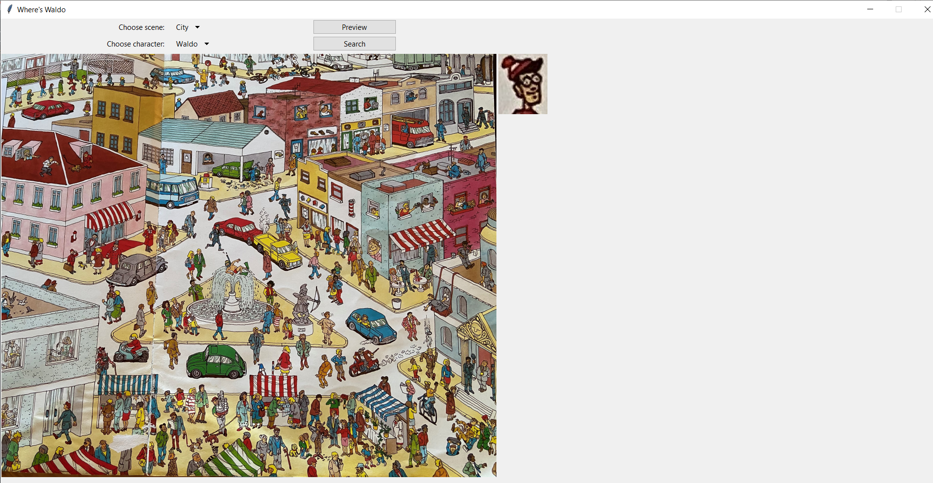

The GUI that is launched when the user clicks “Where’s Waldo”. A default scene (City) and default character to search for (Waldo) are displayed.

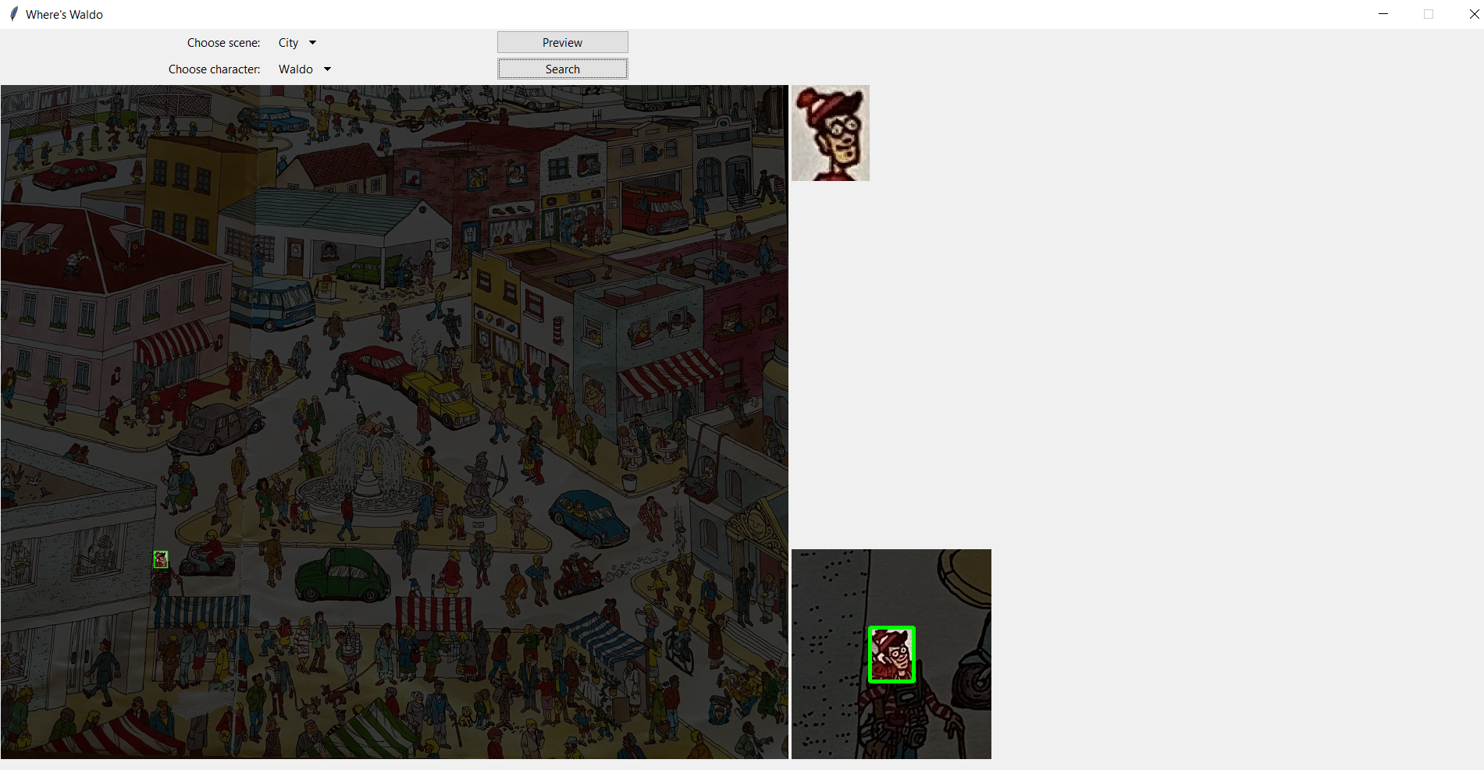

Clicking “Search” finds and outlines the chosen character (Waldo) in the chosen scene (City). *Note that a zoomed in image of where Waldo was found appears in the bottom right of the GUI.

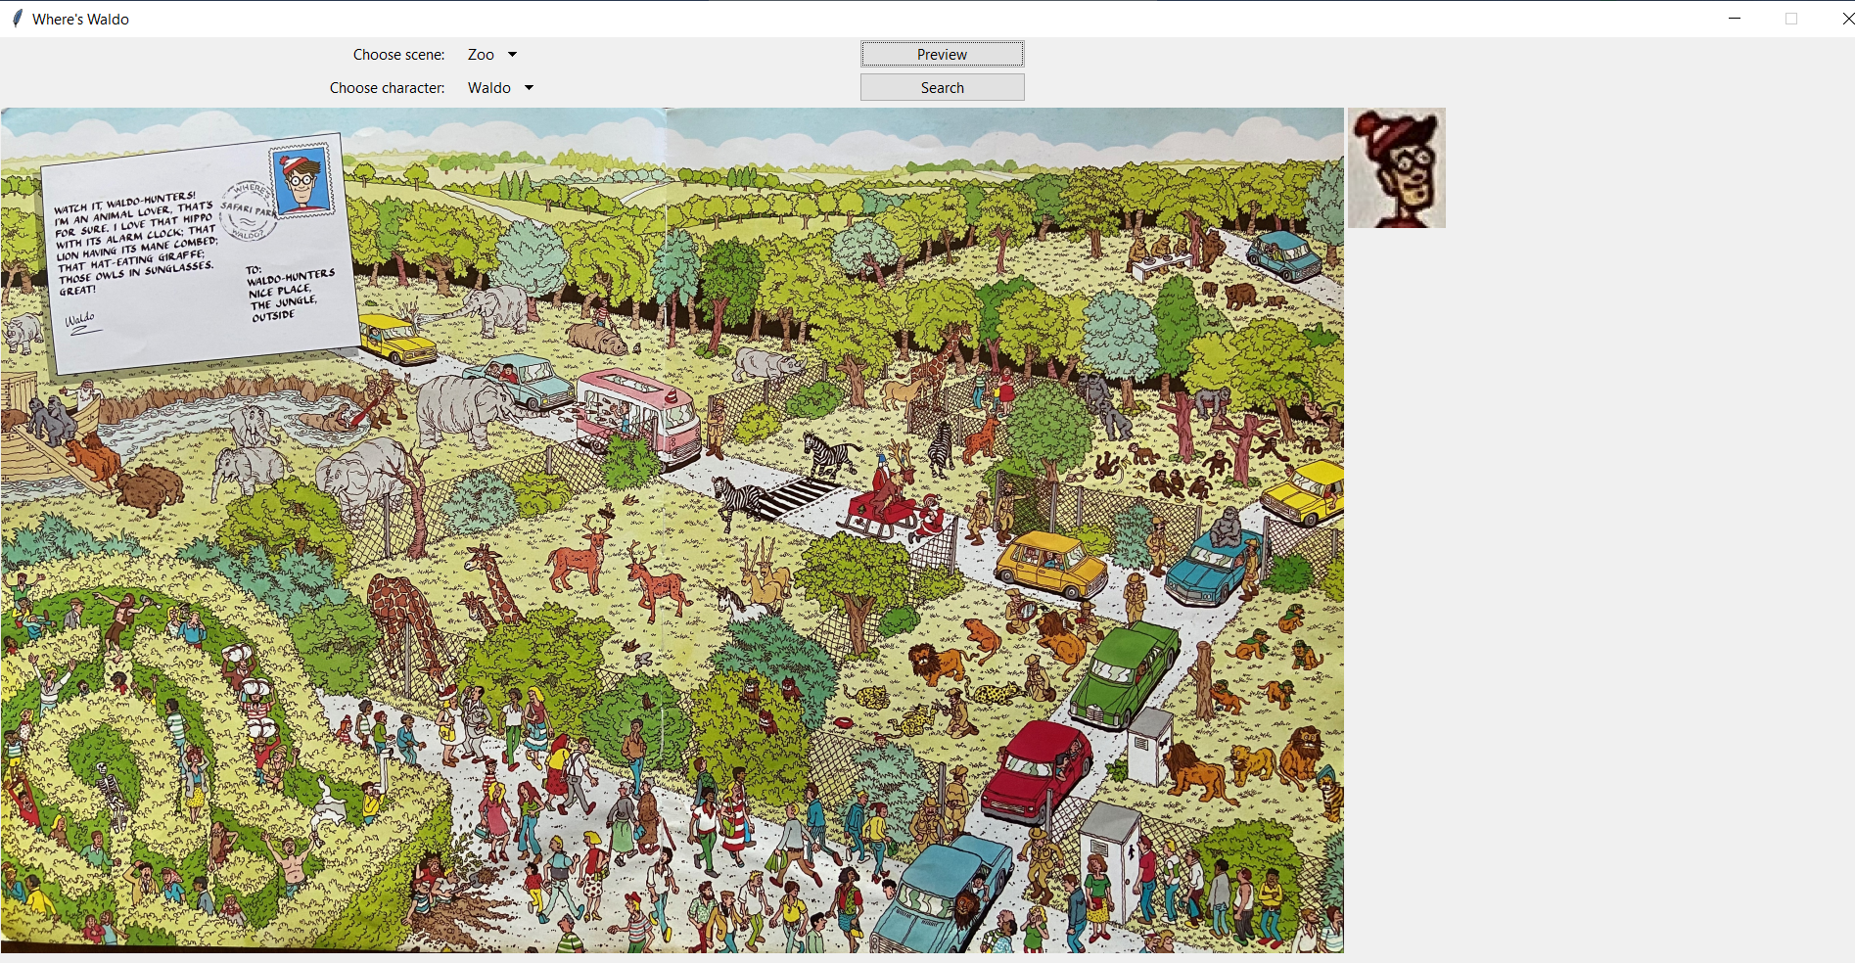

Choosing a new scene (Zoo) and keeping the same character (Waldo), click “Preview” to get to the screenshot above.

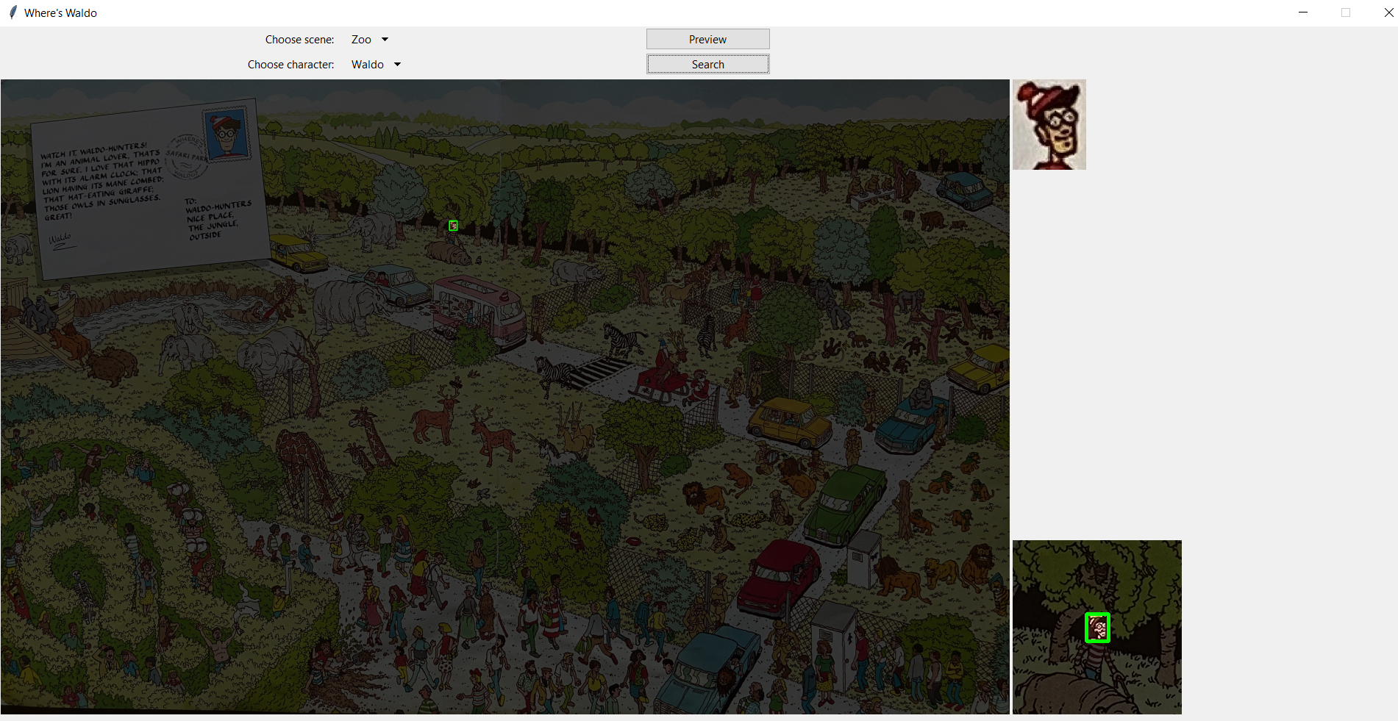

Click “Search” to find Waldo in the Zoo scene.

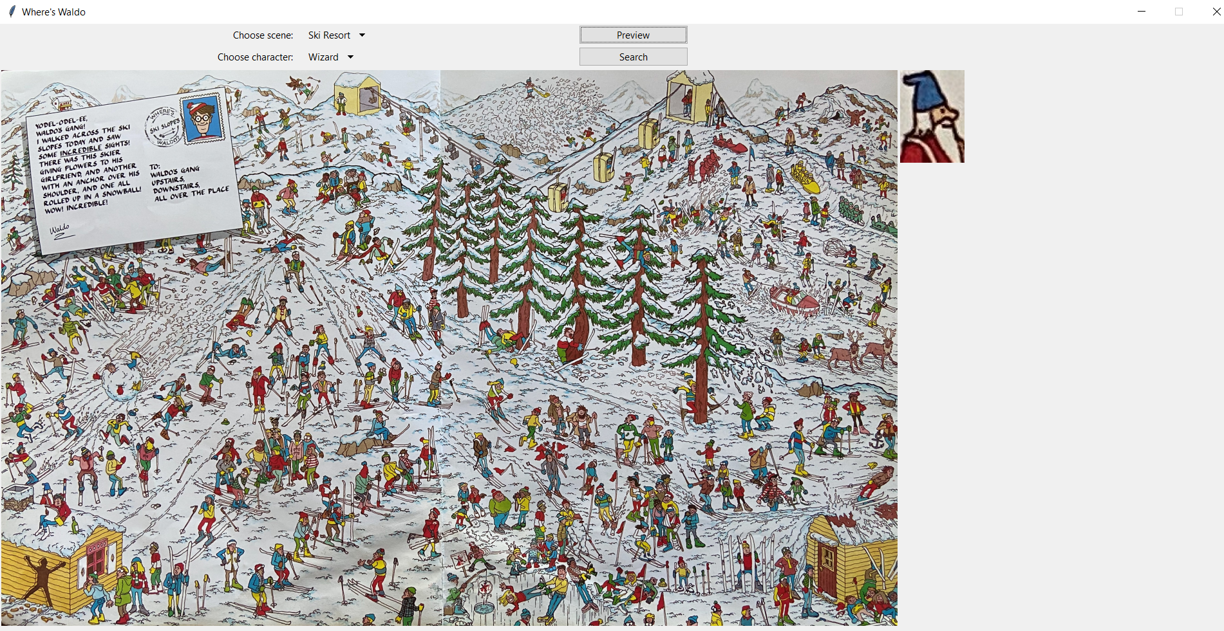

Choose a new scene (Ski Resort) and new character (Wizard), then click “Preview” to get to the screenshot above.

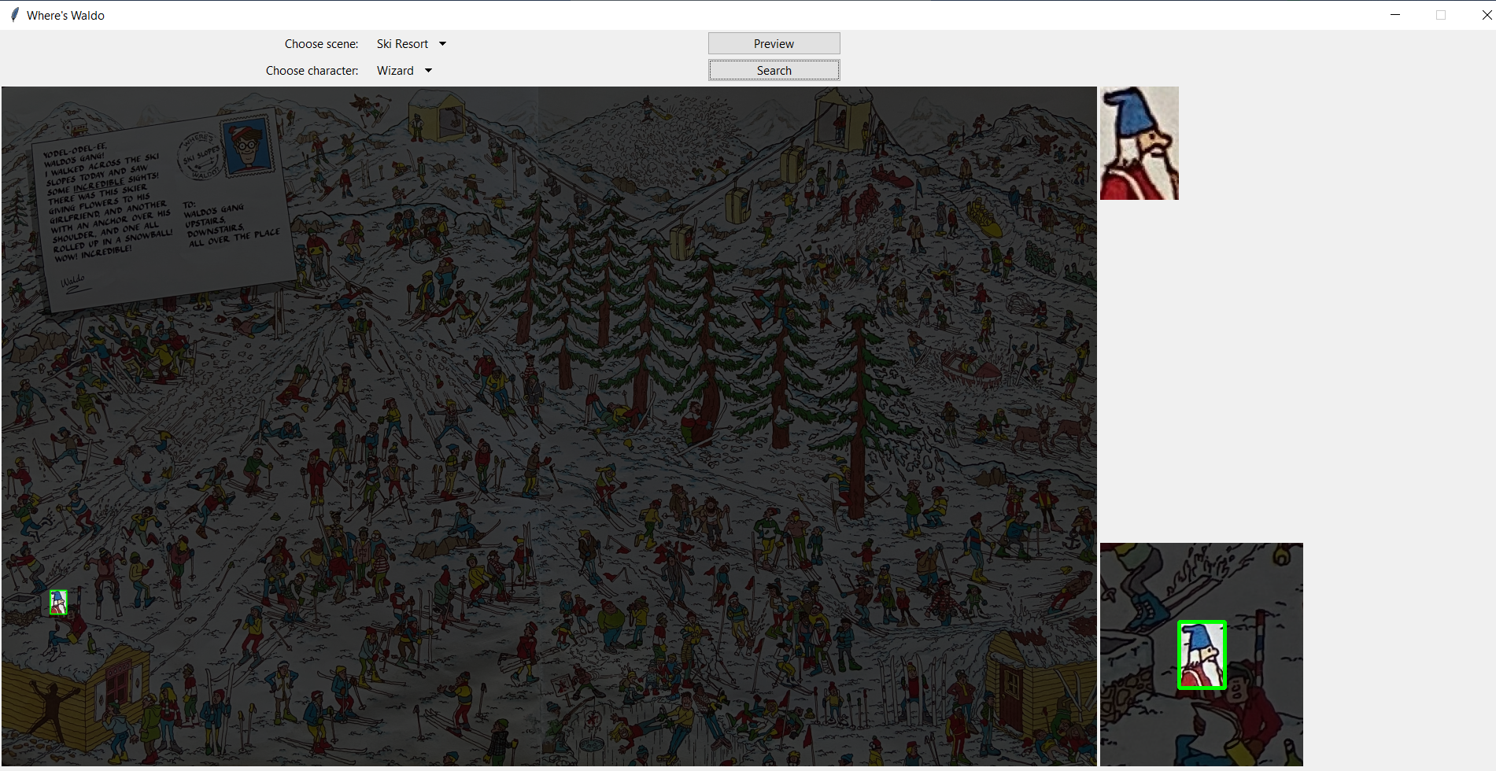

Click “Search” to find Wizard in the Ski Resort scene.

The program finds the user selected Where’s Waldo character within the chosen Where’s Waldo puzzle image according to the test matrix below:

|  |  |  |  |
| --- | --- | --- | --- |
|  | **City** | **Zoo** | **Ski Resort** |
| **Waldo** | Found | Found | Not Found |
| **Wenda** | Found | Found | Found |
| **Wizard** | Found | Found | Found |
| **Odlaw** | Not Found | Found | Found |
| **Woof** | Not Found | Not Found | Not Found |

*Note: In each case where the chosen character was found, the 10-second performance estimate threshold was met.

## Final – Full Scale Where’s Waldo & Friends GUI

For the final program, we decided to increase accuracy by removing Woof from the available characters to search for. Woof’s tail was never able to be found in the puzzle images with the template matching search we were conducting. Further research would need to be done to find something as small and hidden as his tail. We also removed the Department Store puzzle which was giving an error when searching for Wizard Whitebeard.

Building on Phase III, the GUI remains largely unchanged but now includes options to search for Waldo, Odlaw, Wenda, and Wizard Whitebeard in six different puzzles. We also removed the tutorial option so the application opens directly to the Waldo search GUI. Changing the argument numbers in the scaling algorithm changed the results drastically and we found the best run-time/accuracy ration was scaling 2.0 to 0.5 with 10 scales to loop through. The accuracy is 87.5% with finding 21 of 24 characters successfully. The three that were not correct found Odlaw instead of Waldo. To increase accuracy, further research and techniques would need to be used to differentiate between Waldo and Odlaw as they look very similar but with different colors. The table below shows the results of searching the six different puzzles.

|  |  |  |  |  |
| --- | --- | --- | --- | --- |
| 0.5, 2.0, 10 | **Waldo** | **Wenda** | **Wizard** | **Odlaw** |
| **City** | Found | Found | Found | Found |
| **Beach** | Odlaw | Found | Found | Found |
| **Zoo** | Found | Found | Found | Found |
| **Ski Resort** | Odlaw | Found | Found | Found |
| **Train Station** | Odlaw | Found | Found | Found |
| **Museum** | Found | Found | Found | Found |

## 

Conclusions

lessons learned

design strengths

limitations

suggestions for future improvement